// chia trang cho kết quả tìm kiếm

*arr*.slice([*begin*[, *end*]])

cắt arr từ begin tới end-1

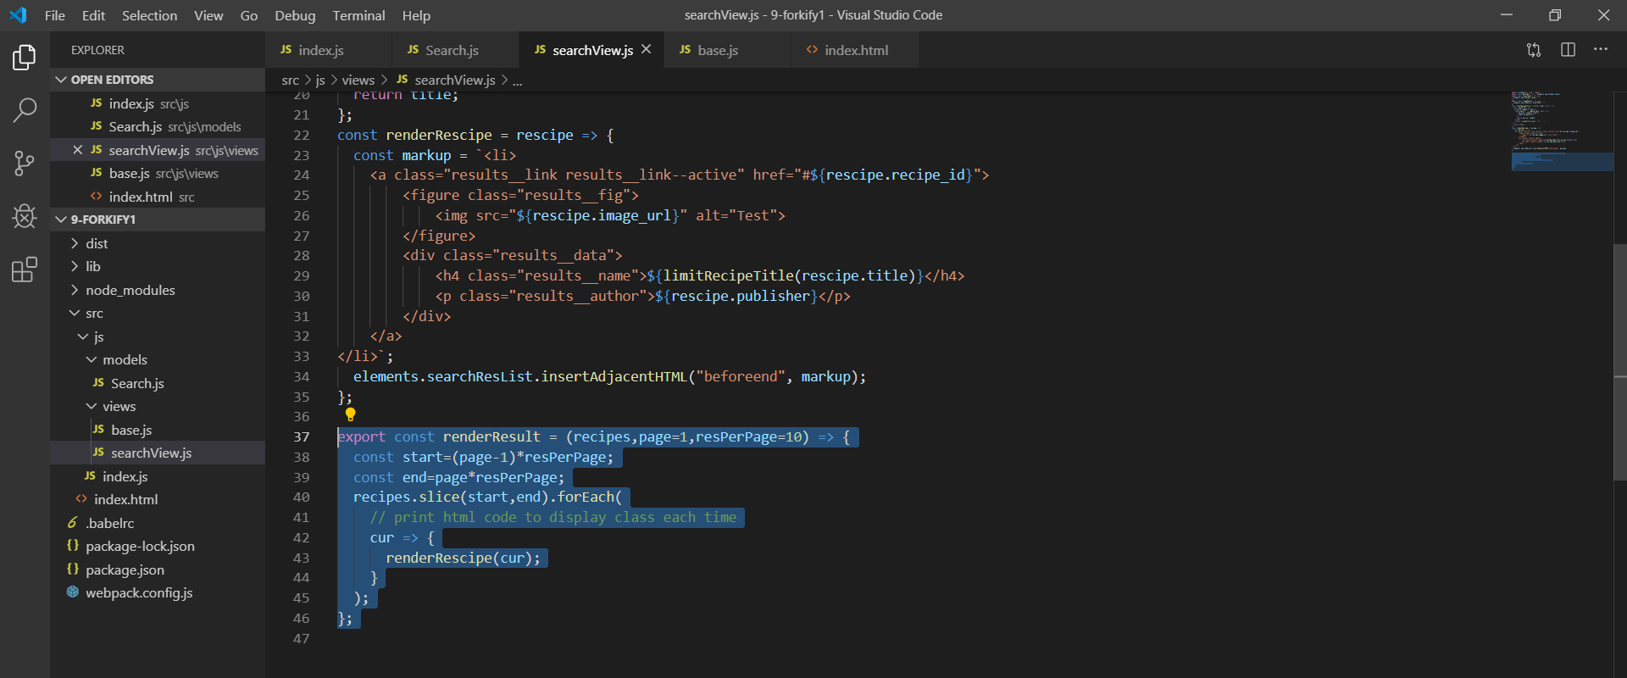

Display 10 res each page

So I need to change renderResult funtion a little

Add 2 arguments page and resPerPage which is store the same value as its name

Detemine start and end res of the page

Use slice to slice arr from start to end -1

Code html cod for each res

inserAdjAcentHtml and for each to display res from start to end -1